Research Paper

Paper’s title should be the fewest possible words that accurately describe the content of the paper

(Center, Bold, 16pt)

**Abdel‑Rahman Hedar1,2, Patricia Melin3, Kennedy Okokpujie4 (10 pt)**

1Department of Computer Science, Faculty of Computers & Information, Assiut University, Assiut, Egypt (8 pt)

2Department of Computer Science in Jamoum, Umm Al-Qura University, Makkah, Saudi Arabia

3Division of Graduate Studies, Tijuana Institute of Technology, Tijuana, Mexico

4Department of Electrical and Information Engineering, College of Engineering, Covenant University, Ota, Nigeria

***Journal of Prevention, Diagnosis and Management of Human Diseases (JPDMHD)***

|  |  |  |
| --- | --- | --- |
| **Article Info** |  | **ABSTRACT** (10 PT) |
| ***Article history:***  Received month dd, yyyy  Revised month dd, yyyy  Accepted month dd, yyyy  Published month dd, yyyy |  | An abstract is often presented separate from the article, so it must be able to stand alone. A well-prepared abstract enables the reader to identify the basic content of a document quickly and accurately, to determine its relevance to their interests, and thus to decide whether to read the document in its entirety. The abstract should be informative and completely self-explanatory, provide a clear statement of the problem, the proposed approach or solution, and point out major findings and conclusions. **The Abstract should be 100 to 200 words in length.** References should be avoided, but if essential, then cite the author(s) and year(s). Standard nomenclature should be used, and non-standard or uncommon abbreviations should be avoided, but if essential they must be defined at their first mention in the abstract itself. No literature should be cited. The keyword list provides the opportunity to add 5 to 7 keywords, used by the indexing and abstracting services, in addition to those already present in the title (10 pt). |
| ***Keywords:***  First keyword  Second keyword  Third keyword  Fourth keyword  Fifth keyword |
|  |
| ***Corresponding Author:***  Kennedy Okokpujie  Department of Electrical and Information Engineering, College of Engineering, Covenant University  Km. 10 Idiroko Road, Canaan Land, Ota, Ogun State, Nigeria  Email: [kennedy.okokpujie@covenantuniversity.edu.nga](mailto:kennedy.okokpujie@covenantuniversity.edu.nga) | | |

Copyright © 2025 The Author(s). This is an open access article distributed under the Creative Commons Attribution License, (http://creativecommons.org/licenses/by/4.0/) which permits unrestricted use, distribution, and reproduction in any medium, provided the original work is properly cited.

1. **INTRODUCTION (12 PT)**

The main text format consists of a flat left-right columns on A4 paper (quarto). The margin text from the left and top are 2.5 cm, right and bottom are 2 cm. The manuscript is written in Microsoft Word, single space, Time New Roman 10 pt, and maximum 12 pages for original research article, or maximum 16 pages for review/survey paper, which can be downloaded at the website: http://ijai.iaescore.com.

A title of article should be the fewest possible words that accurately describe the content of the paper. The title should be succinct and informative and no more than about 12 words in length. Do not use acronyms or abbreviations in your title and do not mention the method you used, unless your paper reports on the development of a new method. Titles are often used in information-retrieval systems. Avoid writing long formulas with subscripts in the title. Omit all waste words such as "*A study of ...*", "*Investigations of ...*", "*Implementation of ...*”, "*Observations on ...*", "*Effect of.....*", “*Analysis of …*”, “Design of…”, etc.

A concise and factual abstract is required. The abstract should state briefly the purpose of the research, the principal results and major conclusions. An abstract is often presented separately from the article, so it must be able to stand alone. For this reason, References should be avoided, but if essential, then cite the author(s) and year(s). Also, non-standard or uncommon abbreviations should be avoided, but if essential they must be defined at their first mention in the abstract itself. Immediately after the abstract, provide a maximum of 7 keywords, using American spelling and avoiding general and plural terms and multiple concepts (avoid, for example, 'and', 'of'). Be sparing with abbreviations: only abbreviations firmly established in the field may be eligible. These keywords will be used for indexing purposes.

Indexing and abstracting services depend on the accuracy of the title, extracting from it keywords useful in cross-referencing and computer searching. An improperly titled paper may never reach the audience for which it was intended, so be specific.

The Introduction section should provide: i) a clear background, ii) a clear statement of the problem, iii) the relevant literature on the subject, iv) the proposed approach or solution, and v) the new value of research which it is innovation (within 3-6 paragraphs). It should be understandable to colleagues from a broad range of scientific disciplines. Organization and citation of the bibliography are made in Institute of Electrical and Electronics Engineers (IEEE) style in sign [1], [2] and so on. The terms in foreign languages are written italic (*italic*). The text should be divided into sections, each with a separate heading and numbered consecutively [3]. The section or subsection headings should be typed on a separate line, e.g., 1. INTRODUCTION. A full article usually follows a standard structure: **1. INTRODUCTION, 2. THE COMPREHENSIVE THEORETICAL BASIS AND/OR THE PROPOSED METHOD/ALGORITHM** *(optional)***, 3. METHOD, 4. RESULTS AND DISCUSSION, and 5. CONCLUSION.** The structure is well-known as **IMRaD** style.

Literature review that has been done author used in the section "INTRODUCTION" to explain   
the difference of the manuscript with other papers, that it is innovative, it are used in the section "METHOD" to describe the step of research and used in the section "RESULTS AND DISCUSSION" to support the analysis of the results [2]. If the manuscript was written really have high originality, which proposed a new method or algorithm, the additional section after the "INTRODUCTION" section and before the "METHOD" section can be added to explain briefly the theory and/or the proposed method/algorithm [4].

1. **LITARATURE REVIW/ RELATED WORK**

Explaining research chronological, including research design, research procedure (in the form of algorithms, Pseudocode or other), how to test and data acquisition [5]–[7]. The description of the course of research should be supported references, so the explanation can be accepted scientifically [2], [4]. Figures 1-2 and Table 1 are presented center, as shown below and cited in the manuscript [5], [8]–[13]. The settlement curves produced at SG1 has been illustrated in Figure 2(a) and SG2 has been illustrated Figure 2(b).

1. **METHOD (12 PT)**

Explaining research chronological, including research design, research procedure (in the form of algorithms, Pseudocode or other), how to test and data acquisition [5]–[7]. The description of the course of research should be supported references, so the explanation can be accepted scientifically [2], [4]. Figures 1-2 and Table 1 are presented center, as shown below and cited in the manuscript [5], [8]–[13]. The settlement curves produced at SG1 has been illustrated in Figure 2(a) and SG2 has been illustrated Figure 2(b).

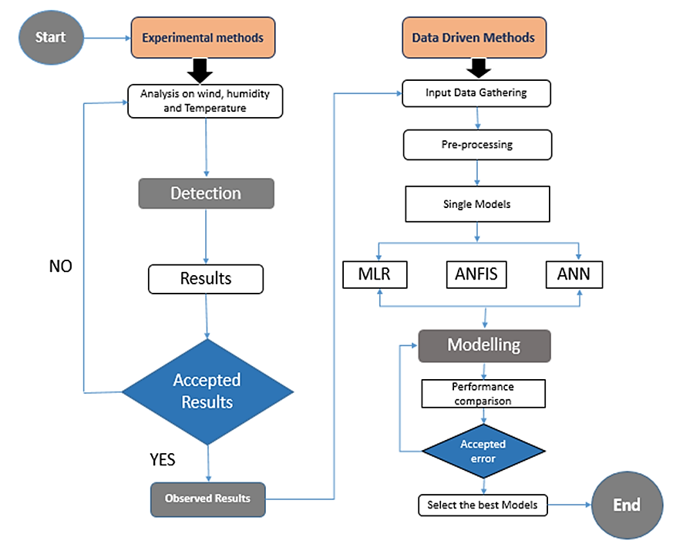

Figure 1. Shows the flowchart of the AI-based models and experimental methods applied

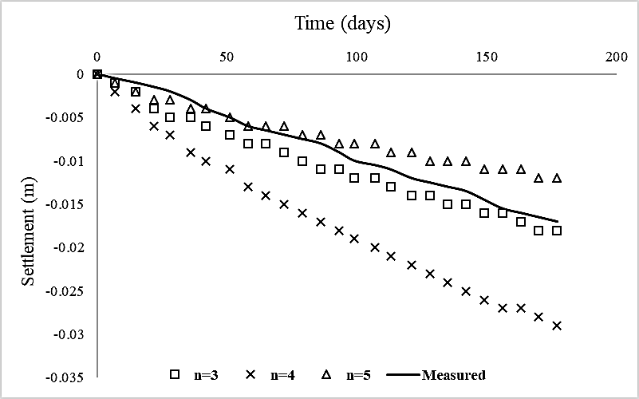

(a)

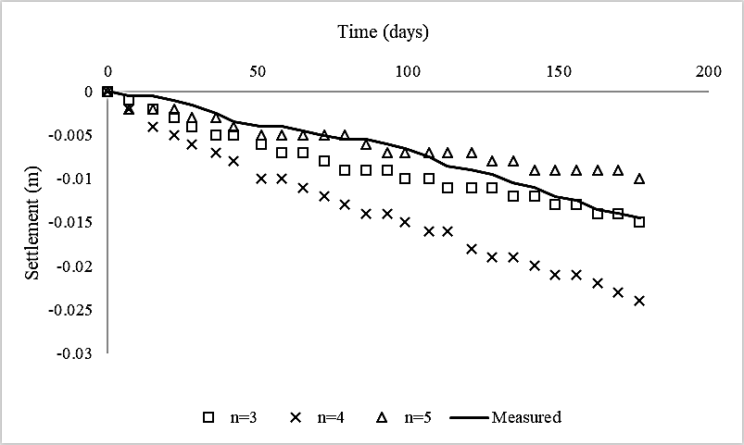

(b)

Figure 2. The relationship of soil settlement and time for (a) SG1 and (b) SG2

Table 1. The performance of ...

|  |  |  |
| --- | --- | --- |
| Variable | Speed (rpm) | Power (kW) |
| x | 10 | 8.6 |
| y | 15 | 12.4 |
| z | 20 | 15.3 |

1. **RESULTS AND DISCUSSION (12 PT)**

In this section, it is explained the results of research and at the same time is given   
the comprehensive discussion. Results can be presented in figures, graphs, tables and others that make   
the reader understand easily [14], [15]. The discussion can be made in several sub-sections.

* 1. **Sub section 1**

Equations should be placed at the center of the line and provided consecutively with equation numbers in parentheses flushed to the right margin, as in (1). The use of Microsoft Equation Editor or MathType is preferred.

$E_{v}-E=\frac{h}{2.m} (k_{x}^{2}+k_{y}^{2}$) (1)

All symbols that have been used in the equations should be defined in the following text.

* 1. **Sub section 2**

Proper citation of other works should be made to avoid plagiarism. When referring to a reference item, please use the reference number as in [16] or [17] for multiple references. The use of ”Ref [18]...” should be employed for any reference citation at the beginning of sentence. For any reference with more than 3 or more authors, only the first author is to be written followed by *et al*. (e.g. in [19]). Examples of reference items of different categories shown in the References section. Each item in the references section should be typed using 8 pt font size [20]–[25].

4.2.1. Subsub section 1

yy

4.2.2. Subsub section 2

zz

1. **CONCLUSION (12 PT)**

Provide a statement that what is expected, as stated in the "INTRODUCTION" section can ultimately result in "RESULTS AND DISCUSSION" section, so there is compatibility. Moreover, it can also be added the prospect of the development of research results and application prospects of further studies into the next (based on result and discussion).

**ACKNOWLEDGMENTS *(if applicable)* (12 PT)**

This section should acknowledge individuals who provided personal assistance to the work but do not meet the criteria for authorship, detailing their contributions. It is imperative to obtain consent from all individuals listed in the acknowledgments.

**FUNDING INFORMATION (12 PT)**

This section should describe sources of funding agency that have supported the work. Authors should state how the research described in their article was funded, including grant numbers if applicable. Include the following (or similar) statement if there is no funding involved: Authors state no funding involved.

**AUTHOR CONTRIBUTIONS STATEMENT (12 PT)**

This journal uses the Contributor Roles Taxonomy (CRediT) to recognize individual author contributions, reduce authorship disputes, and facilitate collaboration. **The recommended number of authors is at least two, with one of them designated as the corresponding author.** The corresponding author will be responsible for all correspondence related to the paper and must ensure that the other authors are included in the communication regarding submission, revision, and publication processes. We encourage authors to include a statement in the paper that shares and accurately describes each author's contribution. To be eligible for authorship, each individual must have contributed to at least one of the following: conceptualization, methodology, formal analysis, or investigation, as well as at least one aspect of writing (either original draft preparation or writing reviews and editing).

|  |  |  |  |  |  |  |  |  |  |  |  |  |  |  |
| --- | --- | --- | --- | --- | --- | --- | --- | --- | --- | --- | --- | --- | --- | --- |
| **Name of Author** | **C** | **M** | **So** | **Va** | **Fo** | **I** | **R** | **D** | **O** | **E** | **Vi** | **Su** | **P** | **Fu** |
| Author 1 name | ✓ | ✓ | ✓ | ✓ | ✓ | ✓ |  | ✓ | ✓ | ✓ |  |  | ✓ |  |
| Author 2 name |  | ✓ |  |  |  | ✓ |  | ✓ | ✓ | ✓ | ✓ | ✓ |  |  |
| Author 3 name | ✓ |  | ✓ | ✓ |  | ✓ |  |  | ✓ |  | ✓ |  | ✓ |  |
| ….. |  |  |  |  |  |  |  |  |  |  |  |  |  |  |
| Author x name |  |  |  |  | ✓ |  | ✓ |  |  | ✓ |  | ✓ |  | ✓ |

|  |  |  |
| --- | --- | --- |
| C : **C**onceptualization  M : **M**ethodology  So : **So**ftware  Va : **Va**lidation  Fo : **Fo**rmal analysis | I : **I**nvestigation  R : **R**esources  D : **D**ata Curation  O : Writing - **O**riginal Draft  E : Writing - Review & **E**diting | Vi : **Vi**sualization  Su : **Su**pervision  P : **P**roject administration  Fu : **Fu**nding acquisition |

*See the examples below:*

|  |  |  |  |  |  |  |  |  |  |  |  |  |  |  |
| --- | --- | --- | --- | --- | --- | --- | --- | --- | --- | --- | --- | --- | --- | --- |
| **Name of Author** | **C** | **M** | **So** | **Va** | **Fo** | **I** | **R** | **D** | **O** | **E** | **Vi** | **Su** | **P** | **Fu** |
| Tole Sutikno | ✓ | ✓ | ✓ | ✓ | ✓ | ✓ |  | ✓ | ✓ | ✓ |  |  | ✓ |  |
| Chuen Ling Toh |  | ✓ |  |  |  | ✓ |  | ✓ | ✓ | ✓ | ✓ | ✓ |  |  |
| Frede Blaabjerg | ✓ |  | ✓ | ✓ |  |  | ✓ |  |  | ✓ | ✓ |  | ✓ | ✓ |

**CONFLICT OF INTEREST STATEMENT (12 PT)**

To ensure fair and objective decision-making, authors must declare any associations that pose a conflict of interest (financial, personal, or professional) in connection with manuscripts. Non-financial competing interests include a declaration of political, personal, religious, ideological, academic, and intellectual competing interests. The authors declare that they have no known competing financial interests or personal relationships that could have appeared to influence the work reported in this paper. If there are no conflicts of interest, please include the following author's statement: Authors state no conflict of interest.

**INFORMED CONSENT *(if applicable)* (12 PT)**

The protection of privacy is a legal right that must not be breached without individual informed consent. In cases where the identification of personal information is necessary for scientific reasons, authors should obtain full documentation of informed consent, including written permission from the patient prior to inclusion in the study. Incorporate the following (or a similar) statement: We have obtained informed consent from all individuals included in this study.

**ETHICAL APPROVAL *(if applicable)* (12 PT)**

When papers talk about using people or animals, authors should make it clear that the research followed all national rules and institutional policies, and it was approved by the authors' institutional review board or a similar committee. The Helsinki Declaration's tenets must guide all investigations involving human subjects. Authors must also identify the committee or review board approving the experiments and provide a statement indicating approval of the research. Incorporate the following (or a similar) statement: The research related to human use has been complied with all the relevant national regulations and institutional policies in accordance with the tenets of the Helsinki Declaration and has been approved by the authors' institutional review board or equivalent committee; or: The research related to animal use has been complied with all the relevant national regulations and institutional policies for the care and use of animals.

**DATA AVAILABILITY (12 PT)**

The data availability statement is a valuable link between a paper’s results and the supporting evidence. It is a brief statement about whether the authors of an article have made the evidence supporting their findings available, and if so, where readers may access it. Data availability statements help to promote transparency and reproducibility in research and to increase the visibility of valuable evidence produced or gathered during the course of research. As part of our commitment to supporting open research, our journal now requires all manuscripts to include a data availability statement in order to be accepted for publication. Examples:

* The data that support the findings of this study are openly available in [repository name] at http://doi.org/[doi], reference number [reference number].
* The data that support the findings of this study will be available in [repository name] [URL / DOI link] following a [6 month] embargo from the date of publication to allow for the commercialization of research findings.
* The data that support the findings of this study are available on request from the corresponding author, [initials]. The data, which contain information that could compromise the privacy of research participants, are not publicly available due to certain restrictions.
* Derived data supporting the findings of this study are available from the corresponding author [initials] on request.
* The data that support the findings of this study are available from [third party]. Restrictions apply to the availability of these data, which were used under license for this study. Data are available [from the authors / at URL] with the permission of [third party].
* The authors confirm that the data supporting the findings of this study are available within the article [and/or its supplementary materials].
* The data that support the findings of this study are available from the corresponding author, [author initials], upon reasonable request.
* Data availability is not applicable to this paper as no new data were created or analyzed in this study.

**REFERENCES (12 PT)**

The main references are international journals and proceedings. All references should be to the most pertinent, **up-to-date sources**, and the **minimum number of references** should be **25** (for original research papers) and **50** (for review papers). References are written in IEEE style. You can access a more comprehensive guide at http://ipmuonline.com/guide/refstyle.pdf. Use a tool such as EndNote, Mendeley, or Zotero for reference management and formatting; choose IEEE style. Please use a consistent format for references—see examples (8 pt):

1. **Journal/Periodicals**

*Basic Format:*

J. K. Author, “Title of paper,” *Abbrev. Title of Journal/Periodical*, vol. *x,* no. *x,* pp*. xxx-xxx,* Abbrev. Month, year, doi: *xxx*.

*Examples:*

* M. M. Chiampi and L. L. Zilberti, “Induction of electric field in human bodies moving near MRI: An efficient BEM computational procedure,” *IEEE Trans. Biomed. Eng.*, vol. 58, pp. 2787–2793, Oct. 2011, doi: 10.1109/TBME.2011.2158315.
* R. Fardel, M. Nagel, F. Nuesch, T. Lippert, and A. Wokaun, “Fabrication of organic light emitting diode pixels by laser-assisted forward transfer,” *Appl. Phys. Lett.*, vol. 91, no. 6, Aug. 2007, Art. no. 061103, doi: 10.1063/1.2759475.

1. **Conference Proceedings**

*Basic Format:*

J. K. Author, “Title of paper,” in *Abbreviated Name of Conf.*, (location of conference is optional), year, pp. *xxx–xxx*, doi: *xxx.*

*Examples:*

* G. Veruggio, “The EURON roboethics roadmap,” in *Proc. Humanoids ’06: 6th IEEE-RAS Int. Conf. Humanoid Robots*, 2006, pp. 612–617, doi: 10.1109/ICHR.2006.321337.
* J. Zhao, G. Sun, G. H. Loh, and Y. Xie, “Energy-efficient GPU design with reconfigurable in-package graphics memory,” in *Proc. ACM/IEEE Int. Symp. Low Power Electron. Design (ISLPED)*, Jul. 2012, pp. 403–408, doi: 10.1145/2333660.2333752.

1. **Book**

*Basic Format:*

J. K. Author, “Title of chapter in the book,” in *Title of His Published Book*, X. Editor, Ed., *x*th ed. City of Publisher, State (only U.S.), Country: Abbrev. of Publisher, year, ch. *x*, sec. *x*, pp. *xxx–xxx.*

*Examples:*

* A. Taflove, *Computational Electrodynamics: The Finite-Difference Time-Domain Method* in Computational Electrodynamics II, vol. 3, 2nd ed. Norwood, MA, USA: Artech House, 1996.
* R. L. Myer, “Parametric oscillators and nonlinear materials,” in *Nonlinear Optics*, vol. 4, P. G. Harper and B. S. Wherret, Eds., San Francisco, CA, USA: Academic, 1977, pp. 47–160.

1. **M. Theses (B.S., M.S.) and Dissertations (Ph.D.)**

*Basic Format:*

J. K. Author, “Title of thesis,” M.S. thesis, Abbrev. Dept., Abbrev. Univ., City of Univ., Abbrev. State, year.

J. K. Author, “Title of dissertation,” Ph.D. dissertation, Abbrev. Dept., Abbrev. Univ., City of Univ., Abbrev. State, year.

*Examples:*

* J. O. Williams, “Narrow-band analyzer,” Ph.D. dissertation, Dept. Elect. Eng., Harvard Univ., Cambridge, MA, USA, 1993.
* N. Kawasaki, “Parametric study of thermal and chemical nonequilibrium nozzle flow,” M.S. thesis, Dept. Electron. Eng., Osaka Univ., Osaka, Japan, 1993.

*In the reference list, however, list all the authors for up to six authors. Use *et al.* only if: 1) The names are not given and 2) List of authors more than 6. *Example*: J. D. Bellamy *et al.*, Computer Telephony Integration, New York: Wiley, 2010.

*See the examples:*

**REFERENCES**

[1] T. S. Ustun, C. Ozansoy, and A. Zayegh, “Recent developments in microgrids and example cases around the world—A review,” *Renew. Sustain. Energy Rev.*, vol. 15, no. 8, pp. 4030–4041, Oct. 2011, doi: 10.1016/j.rser.2011.07.033.

[2] D. Salomonsson, L. Soder, and A. Sannino, “Protection of Low-Voltage DC Microgrids,” *IEEE Trans. Power Deliv.*, vol. 24, no. 3, pp. 1045–1053, Jul. 2009, doi: 10.1109/TPWRD.2009.2016622.

[3] S. Chakraborty and M. G. Simoes, “Experimental Evaluation of Active Filtering in a Single-Phase High-Frequency AC Microgrid,” *IEEE Trans. Energy Convers.*, vol. 24, no. 3, pp. 673–682, Sep. 2009, doi: 10.1109/TEC.2009.2015998.

[4] S. A. Hosseini, H. A. Abyaneh, S. H. H. Sadeghi, F. Razavi, and A. Nasiri, “An overview of microgrid protection methods and the factors involved,” *Renew. Sustain. Energy Rev.*, vol. 64, pp. 174–186, Oct. 2016, doi: 10.1016/j.rser.2016.05.089.

[5] S. Chen, N. Tai, C. Fan, J. Liu, and S. Hong, “Sequence‐component‐based current differential protection for transmission lines connected with IIGs,” *IET Gener. Transm. Distrib.*, vol. 12, no. 12, pp. 3086–3096, Jul. 2018, doi: 10.1049/iet-gtd.2017.1507.

[6] S. Parhizi, H. Lotfi, A. Khodaei, and S. Bahramirad, “State of the Art in Research on Microgrids: A Review,” *IEEE Access*, vol. 3, pp. 890–925, 2015, doi: 10.1109/ACCESS.2015.2443119.

[7] S. Chowdhury, S. P. Chowdhury, and P. Crossley, *Microgrids and Active Distribution Networks*. Institution of Engineering and Technology, 2009.

[8] R. Ndou, J. I. Fadiran, S. Chowdhury, and S. P. Chowdhury, “Performance comparison of voltage and frequency based loss of grid protection schemes for microgrids,” in *2013 IEEE Power & Energy Society General Meeting*, 2013, pp. 1–5, doi: 10.1109/PESMG.2013.6672788.

[9] S. Liu, T. Bi, A. Xue, and Q. Yang, “Fault analysis of different kinds of distributed generators,” in *2011 IEEE Power and Energy Society General Meeting*, Jul. 2011, pp. 1–6, doi: 10.1109/PES.2011.6039596.

[10] K. Jennett, F. Coffele, and C. Booth, “Comprehensive and quantitative analysis of protection problems associated with increasing penetration of inverter-interfaced DG,” in *11th IET International Conference on Developments in Power Systems Protection (DPSP 2012)*, 2012, pp. P31–P31, doi: 10.1049/cp.2012.0091.

[11] P. T. Manditereza and R. Bansal, “Renewable distributed generation: The hidden challenges – A review from the protection perspective,” *Renew. Sustain. Energy Rev.*, vol. 58, pp. 1457–1465, May 2016, doi: 10.1016/j.rser.2015.12.276.

[12] D. M. Bui, S.-L. Chen, K.-Y. Lien, Y.-R. Chang, Y.-D. Lee, and J.-L. Jiang, “Investigation on transient behaviours of a uni-grounded low-voltage AC microgrid and evaluation on its available fault protection methods: Review and proposals,” *Renew. Sustain. Energy Rev.*, vol. 75, pp. 1417–1452, Aug. 2017, doi: 10.1016/j.rser.2016.11.134.

[13] T. N. Boutsika and S. A. Papathanassiou, “Short-circuit calculations in networks with distributed generation,” *Electr. Power Syst. Res.*, vol. 78, no. 7, pp. 1181–1191, Jul. 2008, doi: 10.1016/j.epsr.2007.10.003.

[14] H. Margossian, G. Deconinck, and J. Sachau, “Distribution network protection considering grid code requirements for distributed generation,” *IET Gener. Transm. Distrib.*, vol. 9, no. 12, pp. 1377–1381, Sep. 2015, doi: 10.1049/iet-gtd.2014.0987.

[15] O. Núñez-Mata, R. Palma-Behnke, F. Valencia, A. Urrutia-Molina, P. Mendoza-Araya, and G. Jiménez-Estévez, “Coupling an adaptive protection system with an energy management system for microgrids,” *Electr. J.*, vol. 32, no. 10, p. 106675, Dec. 2019, doi: 10.1016/j.tej.2019.106675.

[16] M. Brucoli and T. C. Green, “Fault behaviour in islanded microgrids,” in *Proceedings of the 19th international conference on electricity distribution, CIRED*, 2007, pp. 0548-(1-4).

[17] I. K. Tarsi, A. Sheikholeslami, T. Barforoushi, and S. M. B. Sadati, “Investigating impacts of distributed generation on distribution networks reliability: A mathematical model,” in *Proceedings of the 2010 Electric Power Quality and Supply Reliability Conference*, Jun. 2010, pp. 117–124, doi: 10.1109/PQ.2010.5550010.

[18] L. K. Kumpulainen and K. T. Kauhaniemi, “Analysis of the impact of distributed generation on automatic reclosing,” in *IEEE PES Power Systems Conference and Exposition, 2004.*, pp. 1152–1157, doi: 10.1109/PSCE.2004.1397623.

[19] A. A. Memon and K. Kauhaniemi, “A critical review of AC Microgrid protection issues and available solutions,” *Electr. Power Syst. Res.*, vol. 129, pp. 23–31, Dec. 2015, doi: 10.1016/j.epsr.2015.07.006.

[20] H. A. Abdel-Ghany, A. M. Azmy, N. I. Elkalashy, and E. M. Rashad, “Optimizing DG penetration in distribution networks concerning protection schemes and technical impact,” *Electr. Power Syst. Res.*, vol. 128, pp. 113–122, Nov. 2015, doi: 10.1016/j.epsr.2015.07.005.

[21] S. Chaitusaney and A. Yokoyama, “An Appropriate Distributed Generation Sizing Considering Recloser-Fuse Coordination,” in *2005 IEEE/PES Transmission &amp; Distribution Conference &amp; Exposition: Asia and Pacific*, pp. 1–6, doi: 10.1109/TDC.2005.1546838.

[22] H. H. Zeineldin, Y. A.-R. I. Mohamed, V. Khadkikar, and V. R. Pandi, “A Protection Coordination Index for Evaluating Distributed Generation Impacts on Protection for Meshed Distribution Systems,” *IEEE Trans. Smart Grid*, vol. 4, no. 3, pp. 1523–1532, Sep. 2013, doi: 10.1109/TSG.2013.2263745.

[23] D. Eltigani and S. Masri, “Challenges of integrating renewable energy sources to smart grids: A review,” *Renew. Sustain. Energy Rev.*, vol. 52, pp. 770–780, Dec. 2015, doi: 10.1016/j.rser.2015.07.140.

[24] M. M. Eissa (SIEEE), “Protection techniques with renewable resources and smart grids—A survey,” *Renew. Sustain. Energy Rev.*, vol. 52, pp. 1645–1667, Dec. 2015, doi: 10.1016/j.rser.2015.08.031.

[25] A. Oudalov *et al.*, “Novel Protection Systems for Microgrids,” 2009. [Online]. Available: http://www.microgrids.eu/documents/688.pdf.

**How to Cite:** Rokan H. Hamad, Sadoon M. Abdullah, Ahmed A. Abdullah, & Dhafer F. Ibrahim. (2025). The protective role of aqueous extract of rosemary leaves and vitamin E in protection against risk of induced hyperlipidemia in male white rats. International Journal of Agriculture and Animal Production, 5(1), 38–48. <https://doi.org/10.55529/ijaap.51.1.>11

**BIOGRAPHIES OF AUTHORS (12 PT)**

In this section, authors are required to provide their professional biography, which should include their academic background, current position, research interests, and any significant contributions to the current study. Additionally, authors should include links to their professional profiles, such as ORCID (*mandatory)* and, *if applicable,* Google Scholar, Scopus Author ID, or Web of Science ResearcherID, etc. This helps establish the author’s academic identity and enhances the visibility of their research.

**Required Information:**

* **Full name**: Include the author's full name as it appears in official records. If preferred, authors may use the format consistent with his/her Scopus profile.
* **Email address for each author**: Provide the author's professional email address to facilitate correspondence.
* **Social media account:**
* **ORCID ID**: This is a mandatory. Each author must include their ORCID iD (https://orcid.org/), which helps link his/her research output to their identity.
* **Google Scholar Profile:** Include the link to the author's Google Scholar profile. If the author does not have a Google Scholar profile, they may create a new one and include the link.
* **Scopus Author ID:** If available, include the Scopus Author ID to enhance visibility on Scopus.
* **Web of Science ResearcherID:** Include the Web of Science ResearcherID. If the author does not have a WoS profile, they may create a new one and include the link.
* **Brief biography:** Provide a concise overview of the author's academic background, research interests, notable publications, and contributions to the current paper. This should be no longer than 150-200 words (9 pt).
* **Professional achievements:** If available, mention any important awards, recognition, or research projects the author has been involved in.
* **Photo Submission:** Authors must submit a clear, professional headshot (3x4 cm). The photo should be of high quality, well-lit, and not blurry. Avoid using photos that are overly casual or low resolution.

*Below is an example of how to format the biography section for each author:*

**BIOGRAPHIES OF AUTHORS (12 PT)**

|  |  |
| --- | --- |
|  | **Abdel‑Rahman Hedar**     holds a Doctor of Informatics degree from Kyoto University, Japan in 2004. He also received his B.Sc. and M.Sc. (Mathematics) from Assiut University, Egypt in 1993 and 1997, respectively. He is currently an associate professor at Computer Science Department in Jamoum, Umm Al-Qura University, Makkah, Saudi Arabia. He is also an associate professor of artifcial intelligence in Assiut University since January 2012. His research includes meta-heuristics, global optimization, machine learning, data mining, bioinformatics, graph theory and parallel programming. He has published over 70 papers in international journals and conferences. From July 2005 to July 2007, he was a JSPS research fellow in Kyoto University, Japan. He can be contacted at email: ahahmed@uqu.edu.sa or hedar@aun.edu.eg. |
|  |  |
|  | **Patricia Melin**     received the D.Sc. degree (Doctor Habilitatus D.Sc.) in computer science from the Polish Academy of Sciences, Warsaw, Poland, with the Dissertation “Hybrid Intelligent Systems for Pattern Recognition using Soft Computing”. She is a Professor of Computer Science in the Graduate Division, Tijuana Institute of Technology, Tijuana, Mexico since 1998. In addition, she is serving as Director of Graduate Studies in computer science and Head of the research group on Computational Intelligence (2000–present). Her research interests are in Type-2 Fuzzy Logic, Modular Neural Networks, Pattern Recognition, Neuro-Fuzzy and Genetic-Fuzzy hybrid approaches., She is currently the President of Hispanic American Fuzzy Systems Association (HAFSA) and is the founding Chair of the Mexican Chapter of the IEEE Computational Intelligence Society. She can be contacted at email: pmelin@tectijuana.mx. |
|  |  |
|  | **Dr. Kennedy Okokpujie**     holds a Bachelor of Engineering (B.Eng.) in Electrical and Electronics Engineering, Master of Science (M.Sc.) in Electrical and Electronics Engineering, Master of Engineering (M.Eng.) in Electronics and Telecommunication Engineering and Master of Business Administration (MBA), Ph.D in Information and Communication Engineering, besides several professional certificates and skills. He is currently lecturing with the department of Electrical and Information Engineering at Covenant University, Ota, Ogun State, Nigeria. He is a member of the Nigeria Society of Engineers and the Institute of Electrical and Electronics Engineers (IEEE). His research areas of interest include Biometrics, Artificial Intelligent, and Digital signal Processing. He can be contacted at email: kennedy.okokpujie@covenantuniversity.edu.ng. |